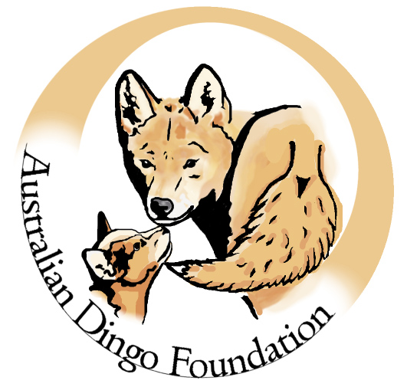

The Macintosh Student Research Grant

In 2015, the Australian Dingo Foundation’s directors established the Macintosh Student Research Grant in honour of Neil William George and patron Ann Macintosh. The aim of the grant is to support emerging scientists undertaking research relating to the Australian dingo.

The nature of the grant

The grant has been set up to support emerging research students who are conducting stimulating and innovative graduate research on the dingo by offering to help cover minor project-related expenses.

The maximum grant awarded is $3000 per year. Only one grant will be awarded for any single project per year. There is no restriction on how the grant may be used as part of the proposed research project. For example, it may be used to bridge a shortfall in existing funding, to instigate pilot studies, to support travel costs for fieldwork (however not conference attendance or workshops), or to purchase equipment required for fieldwork.

Successful applicants will be awarded

- Up to $3000 AUD
- Certificate acknowledging your achievement
- Complimentary year membership to the Australian Dingo Foundation
- Private tour of the Dingo Discovery Sanctuary and Research Centre (travel expenses to the sanctuary at own cost)

Conditions

- Applicants must be actively enrolled in an Honours, Masters, or PhD program at an Australian or International institution. A statement of support from your supervisor, confirming details of your candidature should accompany your application
- Grant funds should be used within the year of receipt
- Successful applicants will be required to provide a written report of their activities at the completion of their program
- Any publications and presentations resulting from the work should acknowledge the support from the Australian Dingo Foundation
- Previous successful applicants are eligible to reapply.

Criteria

We anticipate that competition for the grants will be high. Only clearly written, well-presented and well-constructed applications will be considered. Your project should be of high scientific value, feasible, non-invasive, and importantly must advance our knowledge of the dingo. It should be clear how the proposed funds would be spent and how these fit within any existing projects and/or funding. Students with an academic and research track record is highly valued but not essential. A resume should be attached with the application.

Application process

Applications for the 2023 round close at midnight on the 7th of July. The merits of each application will be judged by the directors of the Australian Dingo Foundation, and the decision will be made by the end of July. The decision of the board is final.

Once the grant is awarded, notices of the successful applicant and project will be posted on the Australian Dingo Foundation website and related social media. Funds will be transferred to the university or institution as soon as possible following the announcement.

Please complete the application form on the following page and email it to dingo@dingofoundation.org using subject heading “Macintosh Student Research Grant” by the deadline.

Further information

For any queries relating to this grant, please contact the Australian Dingo Foundation’s Scientific Director, Dr Bradley Smith: b.p.smith@cqu.edu.au

The Macintosh Student Research Grant

Application form

Project title
Applicant details | Name:  Couse/Program:  Expected completion date:  Phone:  Email:  Postal address:  Qualifications and relevant research experience*:
 | Has an academic CV been attached to this application? Yes No
Host institution | Name:  Campus/location:
Supervisor details | Name:  Position:  School:  Email:
 | Has a letter of support from the supervisor been attached to this application? Yes No
Funds requested from ADF
If this project is being funded from multiple sources, please provide details.

- Summary of the proposed project, including background and aims– Max. 500 words

- Proposed research plan (methods) – Max. 500 words

- Expected outcomes of the project – Max. 300 words

- What are the likely conservation implications for the dingo resulting from your research – Max. 300 words

- Budget justification – Max. 500 words

- What is the current status of the project – Max. 200 words

When completed, please email the application form and any supporting documents to: dingo@dingofoundation.org by midnight on July 7th 2023 (late applications will not be considered). Successful applications will be notified by the end of July.

